### Detecting Building Defects Using Convolutional Neural Networks

# INTRODUCTION

### Overview

The Detection of defects including cracks and spalls on wall surface in high-rise buildings is a crucial task of buildings’ maintenance. Clients are increasingly looking for fast and effective means to quickly and frequently survey and communicate the condition of their buildings.

### Purpose

The approach is being developed with the potential to scale-up and further advance to support automated detection of defects and deterioration of buildings in real-time using mobile devices and drones. Deep learning method of convolutional neural networks (CNN).

# LITERATURE SURVEY

#### Existing problem

People, due to lack of knowledge of defects in there buildings, get into trouble by the sudden natural calamities.

* 1. *Proposed solution*

This model, by taking the required inputs, predicts the defects of the building and let user know it. So that there will not be any interruption further.

# THEORITICAL ANALYSIS

### Block diagram

#### Hardware / Software designing

* + - Strategy: matching the problem with the solution.
    - Dataset preparation and preprocessing. Data collection. Data visualization. Labeling. Data selection. Data preprocessing. Data transformation.
    - Dataset splitting into train data and test data.
    - Modeling. Model training. Model evaluation and testing. Improving predictions with ensemble methods.
    - Model deployment.

# EXPERIMENTAL INVESTIGATIONS

During our investigation, we got to know all the required parameters to predict the building defects.

# FLOWCHART

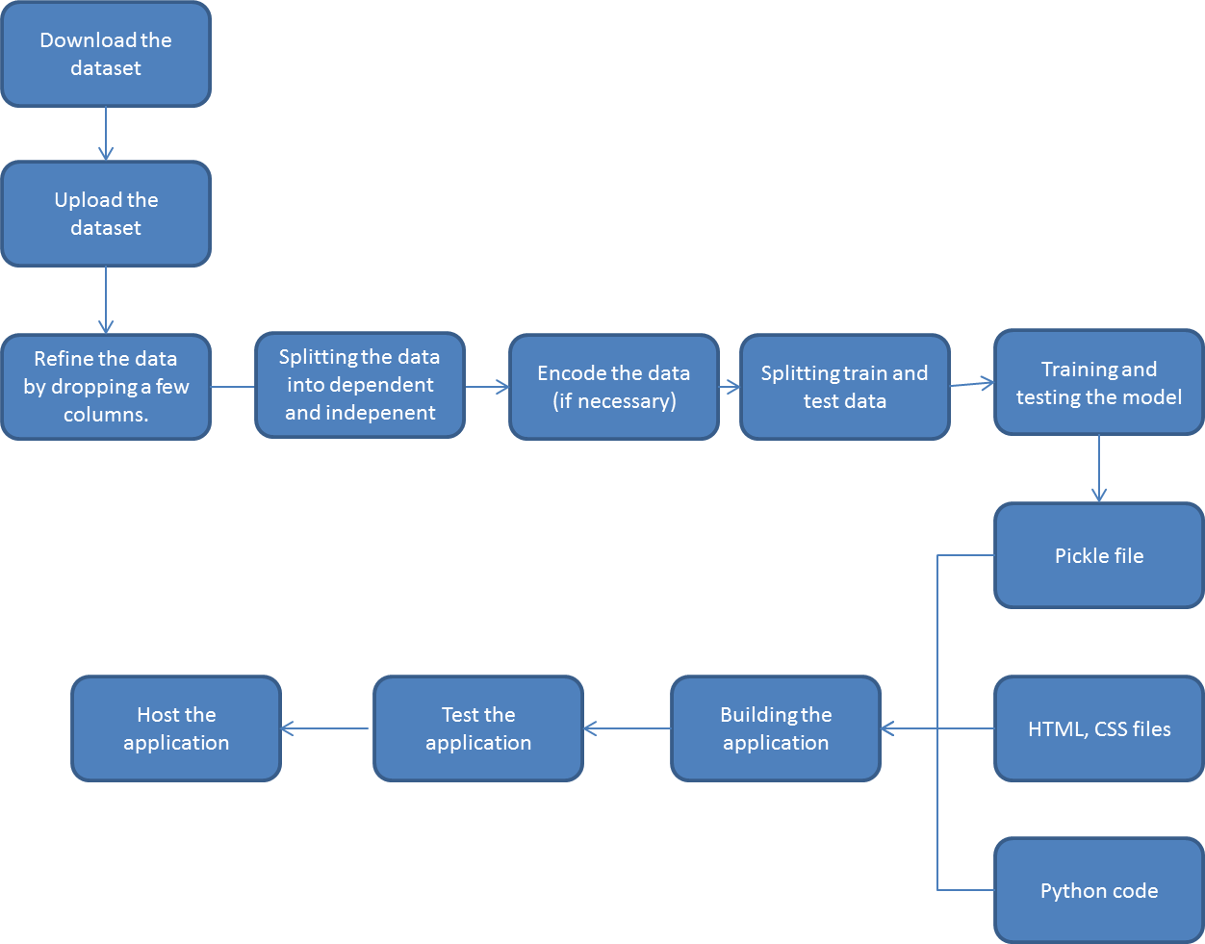

1. **RESULT**

Based on all the inputs entered by the user, the model predicts the building defects and it classify it in four categories like clean,deterioration,mold and stain.

# ADVANTAGES & DISADVANTAGES

#### Advantages:

* Perfect prediction of the building defects and Very accurate performance calculations.
* Extremely easy interface and fast and effective means to quickly and frequently survey and communicate the condition of their buildings.

#### Disadvantages:

* User should have the idea on all the parameters and units of each parameter.

# APPLICATIONS

* Repairs and maintenance work can be done in a proactive and timely manner.
* It reduces the time and labour consuming approach of manual survey.

# CONCLUSION

The important parameter for any building is its stability . Our application predicts the building defects and tells us the stability.

# FUTURE SCOPE

In the evolving population, one must have a safe and secure building. Our application predicts the defects of the building with high accuracy.

# BIBILOGRAPHY APPENDIX

## Model Building

* [Dataset](https://tinyurl.com/carperformancedata)
* [Notebook](https://github.com/SmartPracticeschool/llSPS-INT-182-Car-Performance-Prediction/car%20performance%20prediction%20.ipynb)

## Application Building

* HTML 5 and CSS 3 ﬁles
* Flask